Sennheiser Celebrates 25 Years of Evolution Wireless Microphones
All-digital fifth generation takes over

Wedemark, 2 July 2024 – The closing years of the last century were marked by the rise of hip hop and the revival of teen pop, manifesting in the huge success of boy bands and girl bands. Oscar-winning films American Beauty and The Matrix hit cinemas around the globe and became true classics. For Sennheiser, 1999 marked the birth of its most successful wireless microphone series: Evolution Wireless. Launching just one year after the Evolution wired microphones, Evolution Wireless comprised various radio microphone systems plus an in-ear monitoring set. Since then, the series has gone through several generations of innovation, culminating with its digital transformation in 2020 with the release of Evolution Wireless Digital.

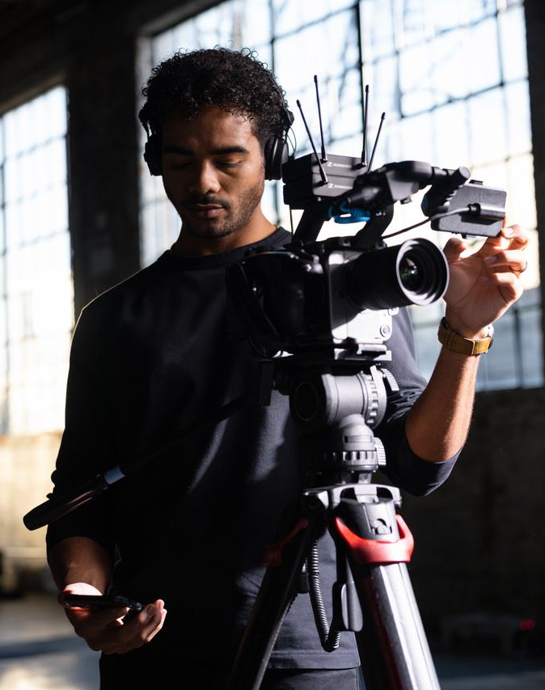
Evolution Wireless Digital has users benefit from the many advantages of digital technology

A courageous decision
Evolution and Evolution Wireless began with a courageous decision that went against a common trend at the time. In the music business in particular, many microphone manufacturers were outsourcing their production to low-cost countries. “Our grandfather and father were trapped: They did not want to compromise the high Sennheiser quality but needed more affordable price points for the music market,” explains Daniel Sennheiser. “Then the Sennheiser engineers suggested that the company might possibly be able to produce high-quality microphones fully automatically – and we took the risk and invested in the necessary production lines.” Andreas Sennheiser adds: “They created the most modern microphone manufacturing line of the time, and the success immediately proved them right: Wireless sales surged tremendously.”

Setup of the initial manufacturing line for evolution microphones

Better and better – in all fields
“From the start, the Evolution Wireless series has benefitted from Sennheiser’s RF expertise in the fields of theatre audio and broadcasting,” says Andreas Sennheiser. “And with every new generation that was launched, our customers and users could be certain to hold the latest in RF wireless technology in their hands.” The second generation of Evolution Wireless was launched in 2004, followed in 2009 by G3 and in 2018 by G4, each generation improving on the previous one in features and usability. The classification into 100, 300 and 500 sub-series indicated the features and scalability to expect from the systems.

The customer base soon extended far beyond the initial music industry focus: the famous evolution wireless “-p” systems attracted videographers, filmmakers and even broadcasters. Small theatres on a budget often went with the 500 series. And the field of business communication applications was catered to by the 300 series.

The latest and best – with the end user in focus
The fifth generation of evolution wireless launched in 2021 with an impactful virtual launch event and it is still being expanded today. This generational change was a major one, as the systems needed to become digital to still present the audio and RF benchmark that Evolution Wireless users had grown accustomed to. Compatibility with the preceding generation – which had been an absolute must previously – was no longer possible, although analogue and digital systems can be operated alongside each other when using the accessories designed for Evolution Wireless Digital.

“To mark this move to digital and increase user awareness, the fifth generation of Evolution Wireless was not simply called G5 but Evolution Wireless Digital,” notes Daniel Sennheiser. “We also did away with the sub-series and instead created user-driven series within the product family.”

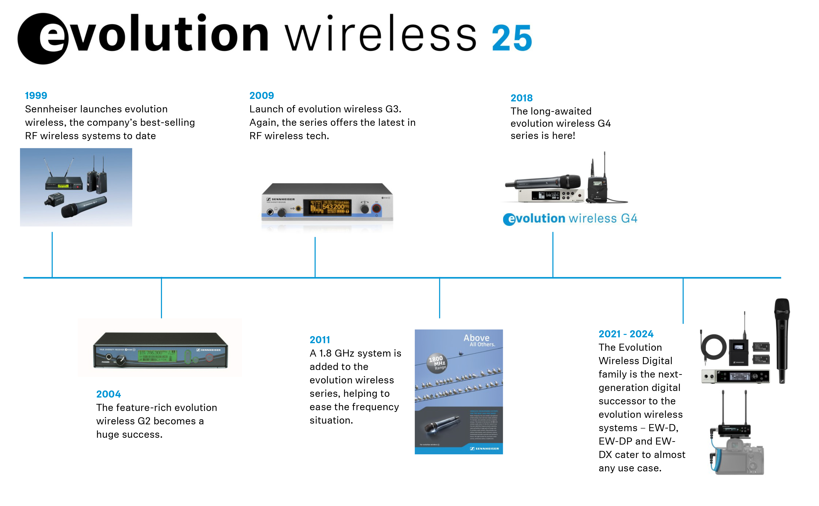

It begins with the customer…
“Focus groups with expert end users from the respective fields contributed massively to the development of the Evolution Wireless Digital family,” says Andreas Sennheiser. “Up and coming bands, live sound engineers, business communications experts, videographers and filmmakers became a part of the product team – voicing their wishes and evaluating the development iterations.”

…and ends with the customer
The results of their work are the sub-series EW-D, which has a focus on bands and musicians, EW-DX for professional live audio, business communications and education applications, and EW-DP for videographers, filmmakers and ENG crews. Turning digital has not only improved the audio quality, but adds many possibilities for users. “For example, bands and speakers can set up their wireless very intuitively via the Smart Assist app – something that was not possible before with a professional UHF wireless system,” says Daniel Sennheiser. “Videographers can remotely unmute an interviewee who has accidentally switched on their mute button. A live sound engineer doesn’t have to crouch in front of the rack but can conveniently link transmitters and receivers via Bluetooth now. An integrator can seamlessly integrate the wireless in their customers larger workflows. What all users get are meticulously engineered systems that were developed with their needs in mind.”

“Digital convenience and seamless workflow integration are key in professional audio today, and with Evolution Wireless Digital, we’re taking the heritage of Evolution Wireless into the digital future of audio,” concludes Andreas Sennheiser.

(Ends)

Evolution Wireless Digital

The images accompanying this media release can be downloaded here.
Visit this page to learn about the biggest benefits of going digital in the music field.

About the Sennheiser brand
We live and breathe audio. We are driven by the passion to create audio solutions that make a difference. Building the future of audio and bringing remarkable sound experiences to our customers – this is what the Sennheiser brand has represented for more than 75 years. While professional audio solutions such as microphones, meeting solutions, streaming technologies and monitoring systems are part of the business of Sennheiser electronic GmbH & Co. KG, the business with consumer devices such as headphones, soundbars and speech-enhanced hearables is operated by Sonova Holding AG under the license of Sennheiser.

www.sennheiser.com
www.sennheiser-hearing.com

Global Pro Audio Press Contact
Stephanie Schmidt
stephanie.schmidt@sennheiser.com
+49 (5130) 600 – 1275

